C.S.DAV PUBLIC SCHOOL
CLASS: 8th
Notes of Maths
Chapters: 01 & 02
Submitted By Mr. Pappu Singh

Chapter: 1

Square Number
Any natural number ‘p’ which can be represented as y², where y is a natural number, then ‘p’ is called a Square Number.
Example
4 = 2²
9 = 3²
16 = 4²
Where 2, 3, 4 are the natural numbers and 4, 9, 16 are the respective square numbers.
Such types of numbers are also known as Perfect Squares.
Some of the Square Numbers
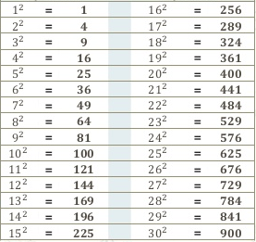

Properties of Square Numbers
- We can see that the square numbers are ending with 0, 1, 4, 5, 6 or 9 only. None of the square number is ending with 2, 3, 7 or 8.
- Any number having 1 or 9 in its one’s place will always have a square ending with 1.
Number | Square Number
1 | 1
9 | 81
11 | 121
19 | 361
21 | 441
- Any number which has 4 or 6 in its unit’s place, its square will always end with 6.
Number | Square Number
4 | 16
16 | 256
24 | 576
36 | 1296
44 | 1936
- Any number which has 0 in its unit’s place, its square will always have an even number of zeros at the end.
Number | Square number
10 | 100
50 | 2500
100 | 10000
150 | 22500
400 | 160000

Some More Interesting Patterns

1. Adding Triangular Numbers
If we could arrange the dotted pattern of the numbers in a triangular form then these numbers are called Triangular Numbers. If we add two consecutive triangular numbers then we can get the square number.
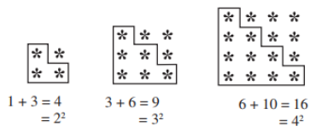

2. Numbers between Square Numbers
If we take two consecutive numbers n and n + 1, then there will be (2n) non-perfect square numbers between their squares numbers.
Example
Let’s take n = 5 and 5² = 25
n + 1 = 5 + 1 = 6 and 6² = 36
2n = 2(5) = 10
There must be 10 numbers between 25 and 36.
The numbers are 26, 27, 28, 29, 30, 31, 32, 33, 34, 35.
3. Adding Odd Numbers
Sum of first n natural odd numbers is n².
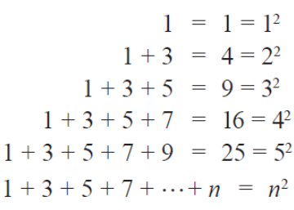
Any square number must be the sum of consecutive odd numbers starting from 1.
And if any natural number which is not a sum of successive odd natural numbers starting with 1, then it will not be a perfect square.

4. A Sum of Consecutive Natural Numbers
Every square number is the summation of two consecutive positive natural numbers.
If we are finding the square of n the to find the two consecutive natural numbers we can use the formula
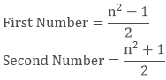
Example
5² = 25
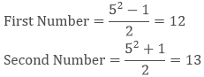
12 + 13 = 25
Likewise, you can check for other numbers like
11² = 121 = 60 + 61

5. The Product of Two Consecutive Even or Odd Natural Numbers
If we have two consecutive odd or even numbers (a + 1) and (a -1) then their product will be (a²- 1)
Example
Let take two consecutive odd numbers 21 and 23.
21 × 23 = (20 - 1) × (20 + 1) = 20² - 1

6. Some More Interesting Patterns about Square Numbers
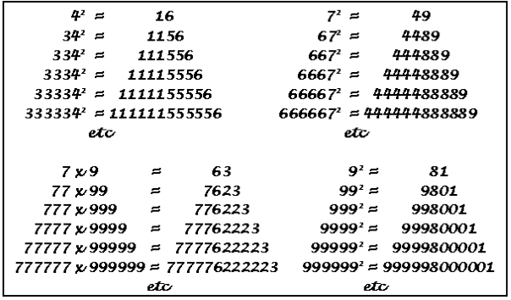

Finding the Square of a Number
To find the square of any number we needed to divide the number into two parts then we can solve it easily.
If number is ‘x’ then x = (p + q) and x² = (p + q)²
You can also use the formula (p + q)² = p² + 2pq + q²
Example
Find the square of 53.
Solution:
Divide the number in two parts.
53 = 50 + 3
53² = (50 + 3)²
= (50 + 3) (50 + 3)
= 50(50 + 3) +3(50 + 3)
= 2500 + 150 + 150 + 9
= 2809

1. Other pattern for the number ending with 5
For numbers ending with 5 we can use the pattern
(a5)² = a × (a + 1)100 + 25
Example
25² = 625 = (2 × 3) 100 + 25
45² = 2025 = (4 × 5) 100 + 25
95² = 9025 = (9 × 10) 100 + 25
125² = 15625 = (12 × 13) 100 + 25

2. Pythagorean Triplets
If the sum of two square numbers is also a square number, then these three numbers form a Pythagorean triplet.
For any natural number p >1, we have (2p) ² + (p² -1)² = (p² + 1)². So, 2p, p²-1 and p²+1 forms a Pythagorean triplet.
Example
Write a Pythagorean triplet having 22 as one its member.
Solution:
Let 2p = 6
P = 3
p² + 1 = 10
p² - 1 = 8.
Thus, the Pythagorean triplet is 6, 8 and 10.
6² + 8² = 10²
36 + 64 = 100

Square Roots
The square root is the inverse operation of squaring. To find the number with the given square is called the Square Root.
2² = 4, so the square root of 4 is 2
10² = 100, therefore square root of 100 is 10
There are two square roots of any number. One is positive and other is negative.
The square root of 100 could be 10 or -10.
Symbol of Positive Square Root
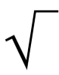

Finding Square Root

1. Through Repeated Subtraction
As we know that every square number is the sum of consecutive odd natural numbers starting from 1, so we can find the square root by doing opposite because root is the inverse of the square.
We need to subtract the odd natural numbers starting from 1 from the given square number until the remainder is zero to get its square root.
The number of steps will be the square root of that square number.
Example
Calculate the square root of 64 by repeated addition.
Solution:
64 – 1 = 63
63 – 3 = 60
60 – 5 = 55
55 – 7 = 48
28 – 13 = 15
48 – 9 = 39
15 – 15 = 0
39 – 11 = 28

2. Prime Factorization
In this method, we need to list the prime factors of the given number and then make the pair of two same numbers.
Then write one number for each pair and multiply to find the square root.
Example
Calculate the square root of 784 using prime factorization method.
Solution:
List the prime factors of 784.
784 = 2 × 2 × 2 × 2 × 7 × 7
√784 = 2 × 2 × 7 = 28

3. Division Method
Steps to find the square root by division method
Step 1: First we have to start making the pair of digits starting from the right and if there are odd number of digits then the single digit left over at the left will also have bar .
Step 2: Take the largest possible number whose square is less than or equal to the number which is on the first bar from the left. Write the same number as the divisor and the quotient with the number under the extreme left bar as the dividend. Divide to get the remainder.
Step 3: Like a normal division process bring the digits in next bar down and write next to the remainder.
Step 4: In next part the quotient will get double and we will right in next line with a blank on its right.
Step 5: Now we have to take a number to fill the blank so that the if we take it as quotient then the product of the new divisor and the new digit in quotient is less than or equal to the dividend.
Step 6: If there are large number of digits then you can repeat the steps 3, 4, 5 until the remainder does not become 0.
Example
Calculate the square root of √729 using division method.
Solution:
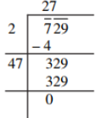
Thus, √729 = 27.

Square Roots of Decimals
To find the square root of a decimal number we have to put bars on the primary part of the number in the same manner as we did above. And for the digits on the right of the decimal we have to put bars starting from the first decimal place.
Rest of the method is same as above. We just need to put the decimal in between when the decimal will come in the division.
Example
Find √7.29 using division method.
Solution:
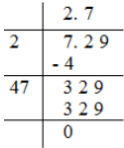
Thus, √7.29 = 2.7
174. 24 10

Estimating Square Root
Sometimes we have to estimate the square root of a number if it’s not possible to calculate the exact square root.
Example
Estimate the square root of 300.
Solution:
We know that, 300 comes between 100 and 400 i.e. 100 < 300 < 400.
Now, √100 = 10 and √400 = 20.
So, we can say that
10 < √300 < 20.
We can further estimate the numbers as we know that 17² = 289 and 18² = 324.
Thus, we can say that the square root of √300 = 17 as 289 is much closer to 300 than 324.

CHAPTER:2

Cubes
Cube is a 3-dimensional figure with all equal sides. If one cube has all the equal sides of 1 cm then how many such cubes are needed to make a new cube of side 2 cm?
8 such cubes are needed, and what if we need to make a cube of side 3 cm with the cubes of side 1 cm? The numbers 1, 8, 27 ...etc can be shown below in the cube.
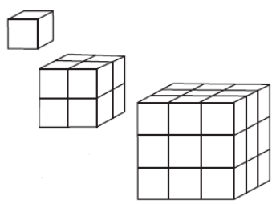
These are known as perfect cubes or cube numbers. This shows that we got the cube numbers by multiplying the number three times by itself.

Cubes of Some Natural Numbers
Number | Cubes | Numbers | Cubes
1 | 1³ = 1 | 11 | 11³ = 1331
2 | 2³ = 8 | 12 | 12³ = 1728
3 | 3³ = 27 | 13 | 13³ = 2197
4 | 4³ = 64 | 14 | 14³ = 2744
5 | 5³ = 125 | 15 | 15³ = 3375
6 | 6³ = 216 | 16 | 16³ = 4096
7 | 7³ = 343 | 17 | 17³ = 4913
8 | 8³ = 512 | 18 | 18³ = 5832
9 | 9³ = 729 | 19 | 19³ = 6859
10 | 10³ = 1000 | 20 | 20³ = 8000
This table shows that
- There are only 10 perfect cubes between 1-1000.
- The cube of an even number is also even.
- The cube of an odd number is also an odd number.

One’s digit of the Cubes
One’s digit of the Cubes of a number having a particular number at the end will always remain same. Let’s see in the following table:
Unit’s digit of number | Last digit of its cube number | Example
1 | 1 | 11³ = 1331, 21³ = 9261, etc.
2 | 8 | 2³ = 8, 12³ = 1728, 32³ = 32768, etc.
3 | 7 | 13³ = 2197, 53³ = 148877, etc.
4 | 4 | 24³ = 13824, 74³ = 405224, etc.
5 | 5 | 15³ = 3375, 25³ = 15625, etc.
6 | 6 | 6³ = 216, 26³ = 17576,etc.
7 | 3 | 17³ = 4913, 37³ = 50653,etc.
8 | 2 | 8³ = 512, 18³ = 5832, etc.
9 | 9 | 19³ = 6859, 39³ = 59319, etc.
10 | 20 | 10³ = 1000, 20³ = 8000, etc.

Some Interesting Patterns
1. Adding Consecutive Odd Numbers
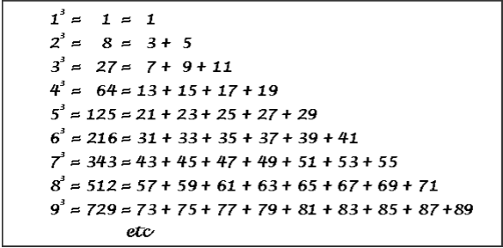
This shows that if we add the consecutive odd numbers then we get the cube of the next number.
2. Cubes and their Prime Factors
Prime factorization of a number is done by finding the prime factors of the number and then pairing it in the group of three. If all the prime factors are in the pair of three then the number is a perfect cube.
Example
Calculate the cube root of 13824 by using prime factorization method.
Solution
First of all write the prime factors of the given number then pair them in the group of three.
Since all the factors are in the pair of three the number 13824 is a perfect cube.

Smallest Multiple that is a Perfect Cube
As we have seen that the group of three prime factors makes a number perfect cube, so to make a number perfect cube we need to multiply it with the smallest multiple of that number.
Example
Check whether 1188 is a perfect cube or not. If not then which smallest natural number should be multiplied to 1188 to make it a perfect cube?
Solution
1188 = 2 × 2 × 3 × 3 × 3 × 11
This shows that the prime numbers 2 and 11 are not in the groups of three. So, 1188 is not a perfect cube
To make it a perfect cube we need to multiply it with 2 × 11 × 11 = 242, so, it will make the pair of 2, 3 and 11.
Hence the smallest natural number by which 1188 should be multiplied to make it a perfect cube is 242.
And the resulting perfect cube is 1188 × 242 = 287496 ( = 66³).

Cube Roots
Finding cube root is the inverse operation of finding the cube.
If 3³ =27 then cube root of 27 is 3.
We write it as ∛27 = 3
Symbol of the Cube Root
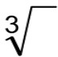
Some of the cube roots are:
Statement | Inference | Statement | Inference
1³ = 1 | ∛1 = 1 | 6³ = 216 | ∛216 = ∛6³ = 6
2³ = 8 | ∛8 = ∛2³ = 2 | 7³ = 343 | ∛343 = ∛7³ = 7
3³ = 27 | ∛27 = ∛3³ = 3 | 8³ = 512 | ∛512 = ∛8³ = 8
4³ = 64 | ∛64 = ∛4³ = 4 | 9³ = 729 | ∛729 = ∛9³ = 9
5³ = 125 | ∛125 = ∛5³ = 5 | 10³ = 1000 | ∛1000 = ∛10³ = 10

Method of finding a Cube Root
There are two methods of finding a cube root
1. Prime Factorization Method
Step 1: Write the prime factors of the given number.
Step 2: Make the pair of three if possible.
Step 3: Then replace them with a single digit.
Step 4: Multiply these single digits to find the cube root.
Example
Find the cube root of 15625 by the prime factorization method.
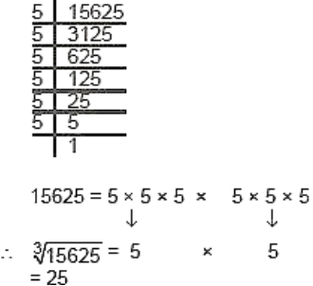
2. Estimation Method
This method is based on the estimation. Let's take the above example.
Step 1: If 15625 is the number then make the group of three digits starting from the right.
15 625
Step2: Here 625 is the first group which tells us the unit’s digit of the cube root. As the number is ending with 5 and we know that 5 comes at the unit’s place of a number only when its cube root ends in 5.
So the unit place is 5.
Step 3: Now take the other group, i.e., 15. Cube of 2 is 8 and a cube of 3 is 27. 15 lie between 8 and 27. The number which is smaller among 2 and 3 is 2. The one’s place of 2 is 2 itself. Take 2 as ten’s place of the cube root of 15625. Thus,

